Step by step in fitting a panel regression

1. Load the dataset

2. Set the data as panel data

3. Fit the fixed effects and random effects model

4. run hausmann test

5. interpret the model

**load the dataset**

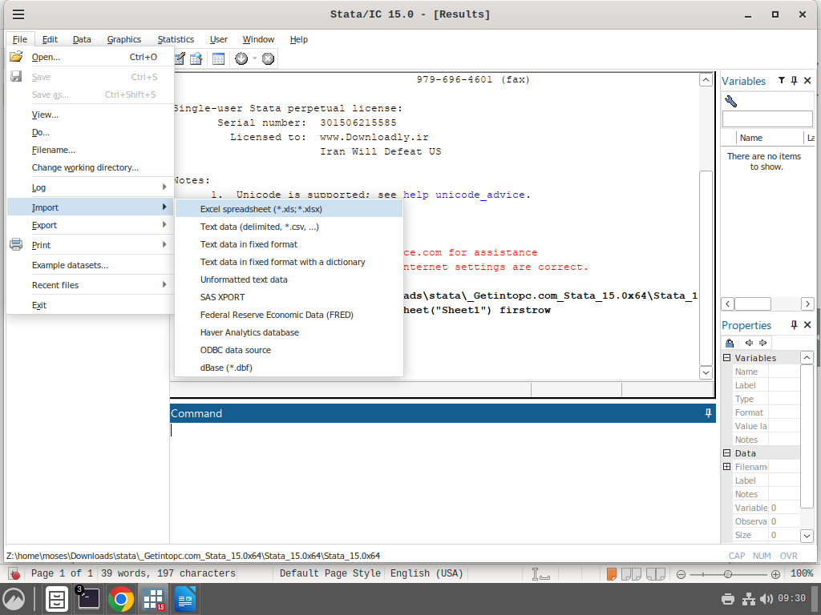

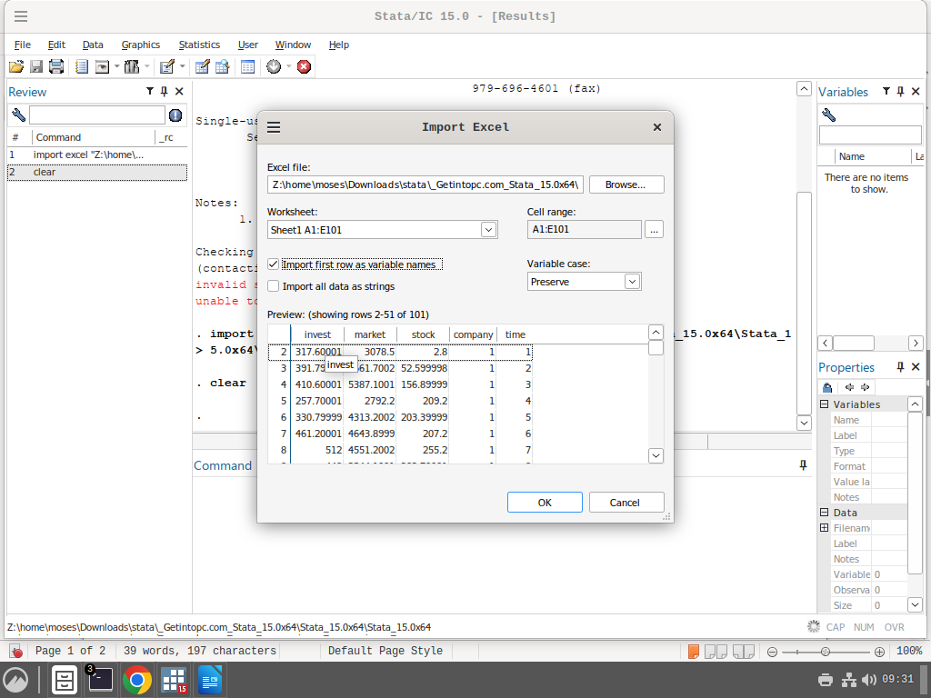

click okay to load the dataset into stata.

**Set the data as panel data**

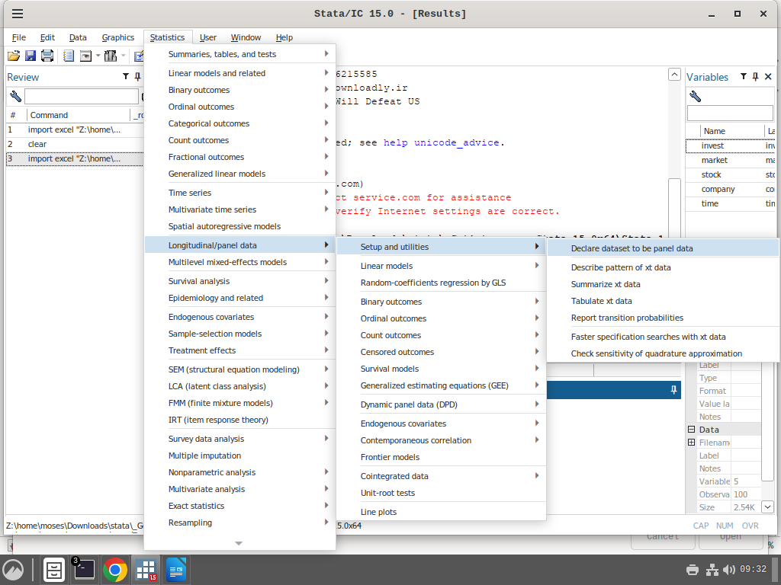

**Remember this its where we will be doing the fitting of a panel regression for this module**

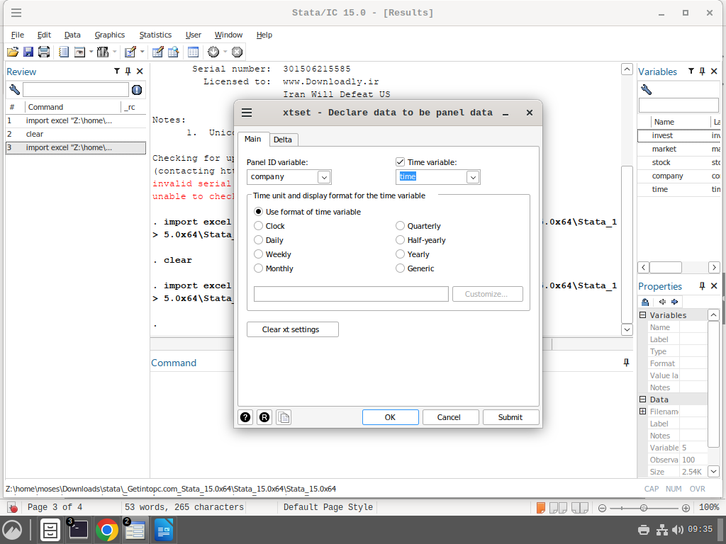

**fit the individual models**

**1. fixed effects model**

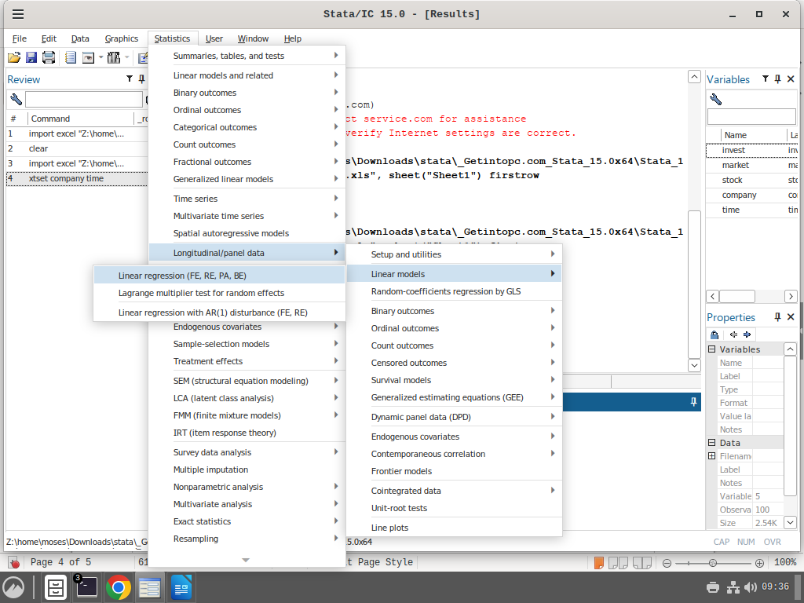

**Here we still gor from longitudinal/panel data to liniear models then to Linear regression (FE,RE, PA, BE). The results of clicking this is shown below**

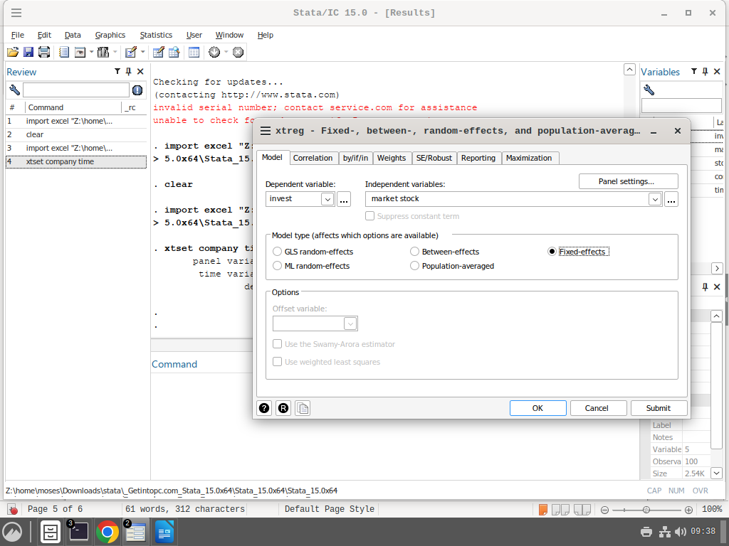

**For the fixed effects model we have checked the fixed effects. The model is still like a linear regression with investment as the dependent variable and independent variables are market and stock.**

here is the output of the model

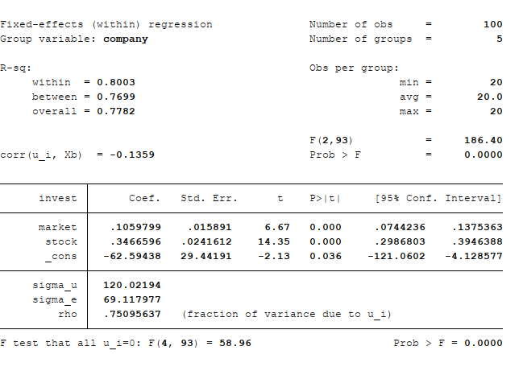

**for more about interpretation of this table look at the file panel101.pdf.**

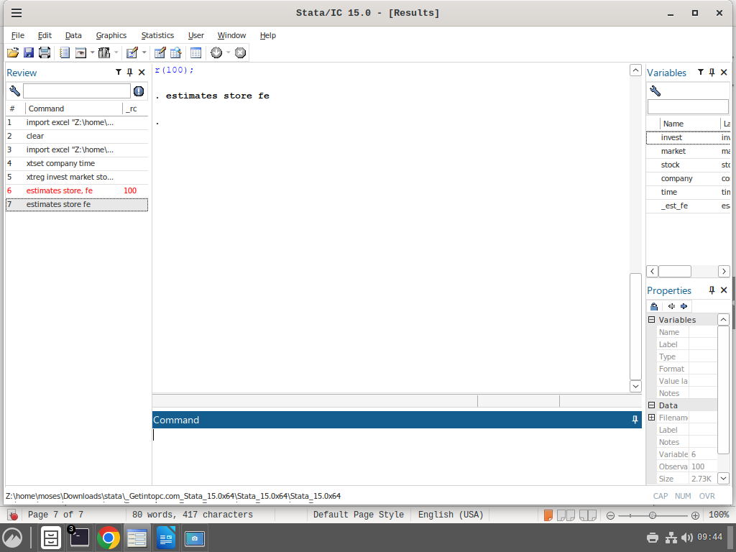

**We use this command estimates store fe to store the model as we will need to call it for the hausmann test.  
estimates store is the name of the command and fe is the name we have given to the model that we have fitted. We will use the same for the random effects model.**

**2. Random effects model**

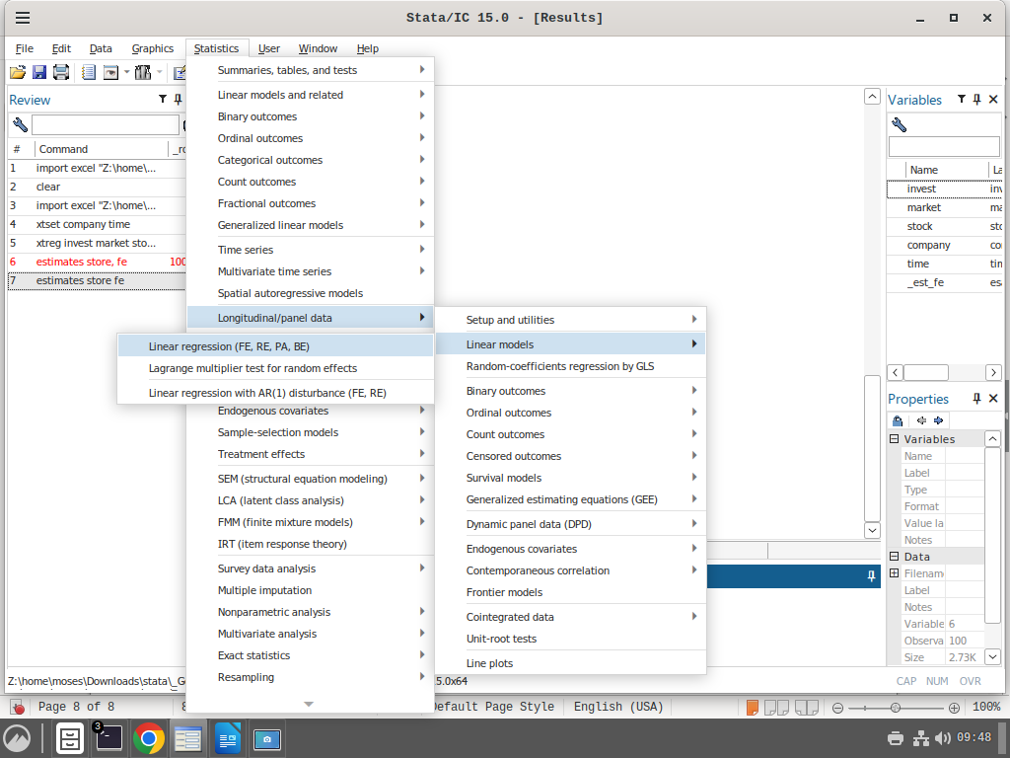

**We are still going to the same place as we did with the fixed effects model**

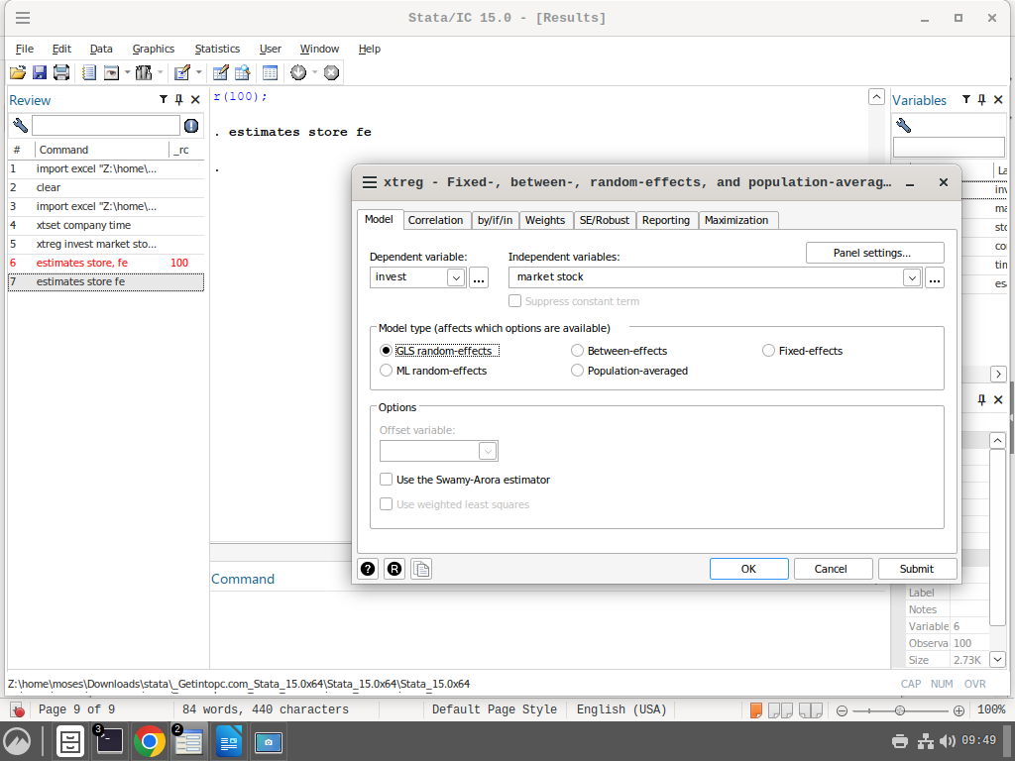

**For the fixed effects model we check he GLS-random effects. The model is still the same as the fixed effects in terms of the dependent and independent variables.**

here is the results of the random effects model

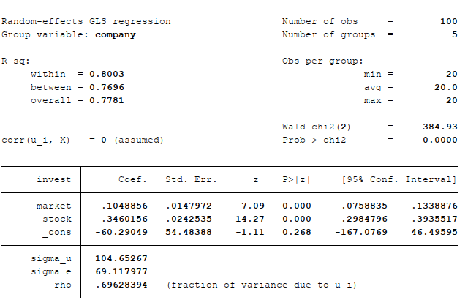

**For interpretation look at panel101.pdf page 41.**

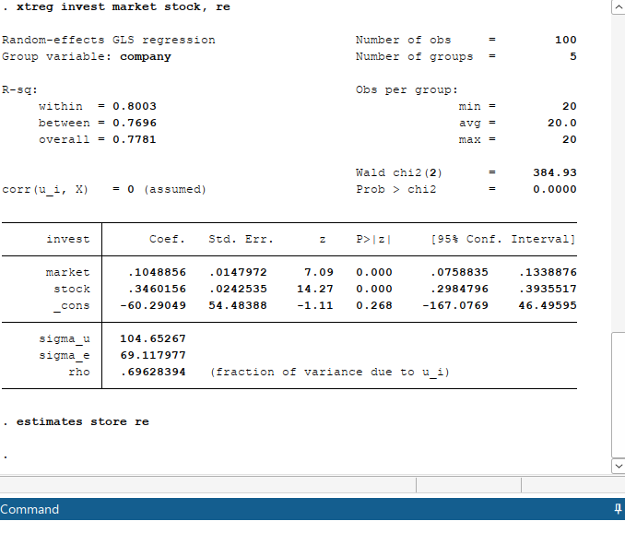**fitting hausman test**

**Remember this command – estimates store re. This time we have the name re for the random effects model.**

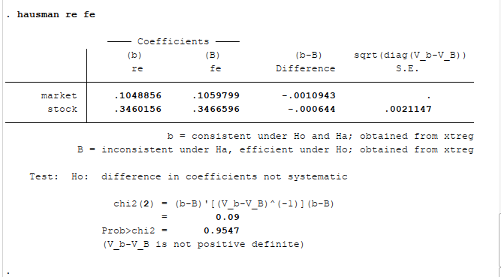

**This is hausman test. The command hausman re fe is used. The names re and fe are the names we gave to the estimates for the random effects and fixed effects model.**

**The p-value here is 0.9547 which means we go with the null hypothesis and hence we select the random effects model.**